**Moria Robinson**

**Department of Biology; Utah State University**

**Progress report for** Grant 205471-A60517: Identifying Resilient Food Webs in a Changing West

**Start date:** March 1st, 2024

This report describes progress toward completion of aims within this grant. Funding was awarded to describe patterns of trait variation among rabbitbrush varieties adapted to different soil and elevational conditions in the Manti-La Sal National Forest (Aim 1); document patterns of insect herbivore diversity and abundance across abiotic gradients (Aim 2); and measure the role of rabbitbrush and its neighbors as foraging habitat for birds (Aim 3). Further detail for each aim is provided below.

**Aim 1: How do traits of a widespread Western shrub (rabbitbrush; *Ericameria nauseosa*) vary with environmental resource availability?** To meet this goal, I grew ten varieties of *Ericameria nauseosa* in the greenhouse for trait measurement, including varieties found across elevation and soil type in the North Zone of the Manti-la Sal National Forest such as *Ericameria nauseosa* var. *salicifolia* (high-elevation; resource-rich soil) and *Ericameria nauseosa* var. *oreophila* (low-elevation; sandy soils). Trait measurement results will be completed and reported by September 2025 (18 months from start date).

***Challenges and solutions:***Initial plans were to measure traits of rabbitbrush in the field, along elevational and soil gradients. However, after extensive site scouting throughout the North Zone of the Manti-La Sal National Forest, I found *E. nauseosa* to have a patchier distribution than anticipated, and to be absent from some soil transitions identified from satellite imagery. Growing plants in the greenhouse will permit greater replication of plant individuals, and minimize environmental effects on traits.

**Figure 1.** *Ericameria nauseosa* varieties currently growing in the greenhouse at USU.

**Aim 2. How do plant traits shape herbivore abundance, diversity, and food web stability?** To meet this goal, plants are being grown in the greenhouse and will be used to measure herbivore performance (bioassay approach) in May 2025. Field sites were established in 2024 for herbivore collection; in 2025, a second set of sites across elevation will be collected and herbivore surveys conducted.

***Challenges and solutions:***As described above, *Ericameria* were found to have a patchier distribution than anticipated (excluding disturbed roadside conditions), and site selection took longer than planned. We identified three sites at three elevations (Figures 2-5), and will add an additional 6 sites in July 2025 now that we are familiar with the area. Herbivore performance and community structure results will be completed and reported by September 2025 (18 months from start date).

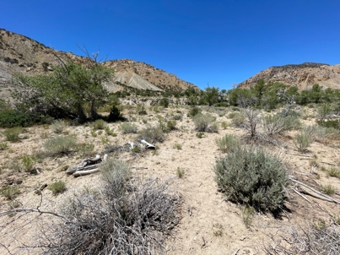

Huntington Creek

Ferron Creek Wash

Upper Joe’s Reservoir

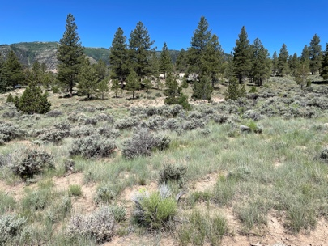

**Figure 2.** Study sites were established at three elevations. From North to South on map: Huntington Creek (mid-elevation; 7043ft); Upper Joe’s Reservoir (high; 7693ft); and Ferron Creek Wash (low; 6355ft).

**Aim 3: What is the importance of rabbitbrush and other dominant shrub species to higher trophic levels?** 180 non-toxic clay caterpillars were deployed at three sites (see Figure 2) with distinct vegetation types. Specifically, at each site, three caterpillars were placed on each of 10 *Ericameria nauseosa* plants; and on 10 of the two dominant co-occurring shrub species at each site. *Artemisia tridentata* was a dominant co-ocurring shrub at each site. The third shrub species was *Cercocarpus montanus* (Upper Joe’s Reservoir); *Cercocarpus ledifolius* (Huntington Creek); and *Atriplex confertifolia* (Ferron Creek Wash) (Figure 3). Caterpillars were retrieved after 10 days. Predation marks are currently being classified (bird; mammal; invertebrate) for data analysis (Figure 3).

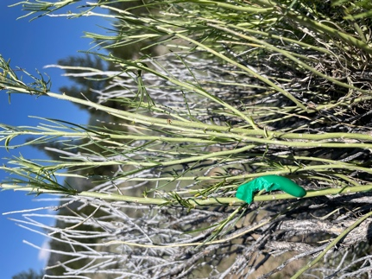 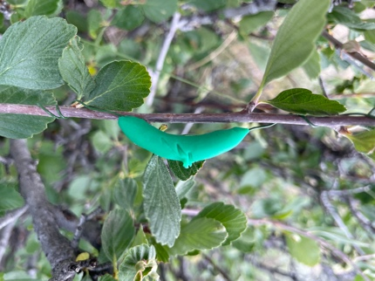

**Figure 3.** Clay caterpillars on *E. nauseosa, C. montanus, A. confertifolia*, and *A. tridentata*, with evidence of predation.